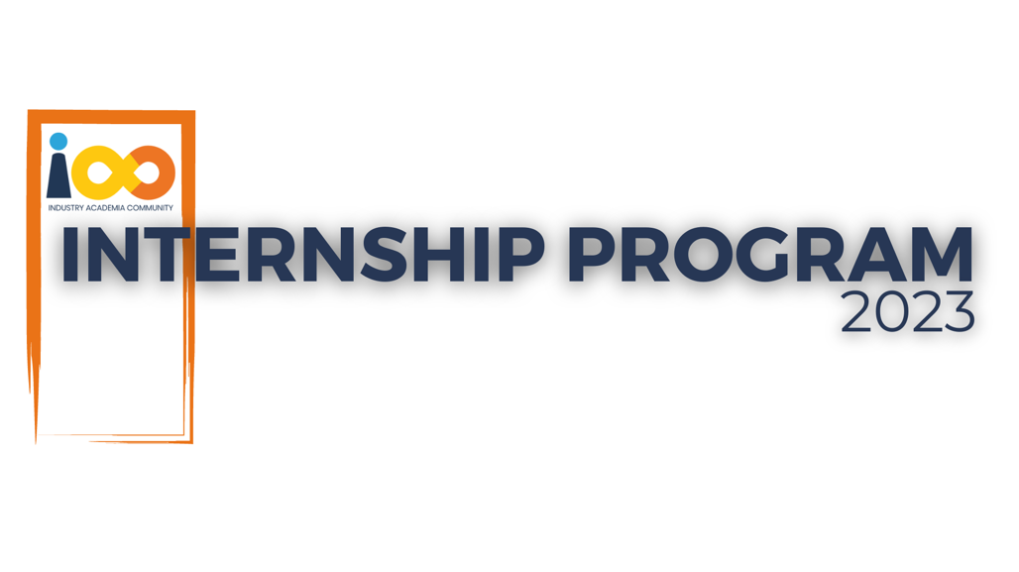

PROJECT REPORT

DATA ANALYTICS  
  
TOPIC: Comprehensive Event and Student Data Analytics: Empowering Organizational Insights with Python

|  |  |  |  |
| --- | --- | --- | --- |
| **Created By:** | Mayoor Moolya | **Approved By:** | Suraj Mane |
| **Created On:** | 20-09-2023 | **Approved On:** | DD-MMM-YYYY |

**INDEX**

**1** **SUMMARY** 1

**2** **INTRODUCTION** 2

2.1 Background 2

2.2 Stakeholders 2

2.3 Objectives 2

**3** **METHODOLOGY** 3

3.1 Considerations & Assumption 3

3.2 Approach 3

3.3 Activities 3

**4** **TARGETTED V/S ACHIEVED OUTPUT** 4

**5** **CONCLUSION** 4

**6** **APPENDICES** 5

6.1 Appendix A – Title 5

* **PROJECT DETAILS**

|  |  |  |  |
| --- | --- | --- | --- |
| **Project Name** | Comprehensive Event and Student Data Analytics:  Empowering Organizational Insights with Python | | |
| **Project Sponsor** | TUSHAR TOPALE | | |
| **Project Manager** | HARSHADA TOPALE | | |
| **Start Date** | 31-07-2023 | **Completion Date** | 25-09-2023 |

# **SUMMARY**

**Project Title:** Comprehensive Analysis of Student Interns

**Problem Statement:** The project addresses the absence of insights into the relationship between a student's economic background, academic performance, competence, and expected salary. This knowledge gap hinders informed decision-making in areas such as student support, academic programs, and career development.

**Methodology:** The project utilizes a comprehensive dataset with student attributes to conduct statistical analyses and data visualizations. Techniques include regression analysis, data clustering, and data visualization tools like Matplotlib and Seaborn.

**Expected Deliverables:** Insights, reports, and visualizations that shed light on the complex relationship between students' academic performance, economic backgrounds, and career aspirations.

**Long-Term Benefits:**

1. Informed decision-making for student support and program enhancements.
2. Improved academic outcomes and career prospects for students.
3. Enhanced resource allocation based on data-driven insights.

Top of Form

# **INTRODUCTION**

## Background

## Millions of students apply for internships/jobs every year, resumes play an important role In playing the first impression. The recruiters spend a max of 2-3 minutes reviewing a Cloud Counselage resume after it landed in their mailbox or Job board, ATS application. Surprising more than 70% of resumes get rejected in the Initial screening:

## Stakeholders

Project Team: This includes project managers, analysts, data scientists, and other team members responsible for executing the project.

Organization Leadership: Senior management and executives who oversee and support the project's objectives.

Academic Staff: Professors, teachers, and academic advisors who may benefit from insights into student performance and success factors.

## Objectives

We aim to conduct a comprehensive analysis of our student interns to gain insights about relationship between their academic performance, event participation, career aspiration and factors influencing their success. We have collected a dataset containing various attributes for coch student

# **METHODOLOGY**

## Considerations & Assumption

In the course of this project, we consider the sensitivity of student data, prioritize data quality, recognize complex relationships among factors, and adhere to strict ethical guidelines. Assumptions include data accuracy, relative data homogeneity, consistent data collection, ethical compliance, and access to necessary resources. These guide our project approach, ensuring responsible data handling and meaningful insights.

## Approach

* Data Collection and Preprocessing: Gather and clean the dataset.
* Exploratory Data Analysis (EDA): Understand data patterns using visualizations and statistics.
* Hypothesis Testing: Formally assess relationships in the data.
* Data Visualization: Use visuals for clarity and interpretation.
* Regression and Cluster Analysis: Quantify relationships and segment the student population.
* Ethical Data Handling: Ensure responsible data usage.

## Activities

The project followed a structured approach, beginning with defining clear objectives and collecting data. Data preprocessing and Exploratory Data Analysis (EDA) helped understand data patterns. Hypotheses were validated through statistical tests and regression analysis. Cluster analysis segmented the student population. Ethical data handling was maintained. Iterative analysis and documentation ensured accurate insights, with results communicated effectively through reports and visualizations, incorporating stakeholder feedback.

# **TARGETTED V/S ACHIEVED OUTPUT**

In the project plan, several targeted outputs were identified to measure the project's success. Below, I outline these targeted outputs and provide a brief description of what has been achieved, along with the reasons for any deviations:

1. Timely Data Collection:

Targeted Output: Completing data collection within the specified timeframe.

Achievement: Data collection was completed on schedule.

2. Data Preprocessing Accuracy:

Targeted Output: Ensuring data preprocessing accuracy with minimal missing values and errors.

Achievement: Data preprocessing achieved a high level of accuracy, addressing missing values and errors effectively.

3. Comprehensive Exploratory Data Analysis (EDA):

Targeted Output: Conducting an in-depth EDA to uncover data patterns and insights.

Achievement: EDA was comprehensive and provided valuable insights into the dataset.

# **CONCLUSION**

**Conclusion:**

This analysis equips stakeholders with data-driven insights for informed decision-making. It enhances resource allocation, event planning, and student support efforts. Understanding the correlation between leadership roles and outcomes can guide mentorship programs

**Future Scope:**

Future projects can explore predictive modeling, external data integration, machine learning, longitudinal analysis, and real-time feedback mechanisms to deepen our understanding and further improve support for student success. This project sets the stage for ongoing enhancements in our student internship and career development initiatives.

# **APPENDICES**

## Appendix A – Title

|  |  |
| --- | --- |
| Component Title | **Description** |
| Data Collection | Details on data sources and collection methods. |
| Data Preprocessing | Steps and procedures for data cleaning and preprocessing. |
| EDA Findings | Key insights and visualizations from the Exploratory Data Analysis (EDA) phase. |
| Regression Analysis | Details of regression models used for analysis. |
| Cluster Analysis | Information on cluster analysis results and segmentation. |
| Ethical Guidelines | Overview of ethical data handling guidelines followed during the project. |